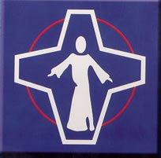
‘Together we can achieve our best!’
St Stephen’s RC Primary School

St Stephen’s Church and St Stephen’s RC Primary School
Thursday Masses Autumn Term 2021
Thursday 2nd September | No Mass- First Day Back
Thursday 9th September | Year 6
Thursday 16th September | Year 5
Thursday 23rd September | Year 4
Thursday 30th September | Year 3
Thursday 7th October | Year 2
Thursday 14th October | Year 1
Thursday 21st October | Reception and Year 6
Monday 1st November | Whole School Mass- All Saints Day
Thursday 11th November | Reception and Year 6
Thursday 18th November | Year 5 and Year 1
Thursday 25th November | Year 2 and Year 4
Thursday 2nd December | Year 3, 5 and 6 Mass
Thursday 16th December | Year 1, 2 and 4 Mass
Thursday 16th December | Whole School Mass for Christmas

